**39.How to sort pandas data frame in python?**

**Objective:**

* To sort the pandas data frame by its values and columns using python.

**Process:**

* Import the library.
* Read the sample data set.
* column in an ascending order.
* column in an descending order.
* Sort by multiple columns.

**Input:**

* Data set(csv file).

**Output:**

* Ascending and descending multiple rows and columns.

**Source code:**

#import libraries

import pandas as pd

#read the data set

data=pd.read_csv('/home/soft27/soft27/Sathish/

Pythonfiles/Employee.csv')

#creating data frame

df=pd.DataFrame(data)

#sorting in ascending

print("Sorting in ascending order")

print(df.sort_values(by=['name'],inplace=False))

#sorting in descending

print("Sorting in descending order")

print(df.sort_values(by=['salary'],inplace=False,

ascending=False))

#sort multiple columns in ascending

print("Ascending by multiple columns")

print(df.sort_values(by=['age','salary'], inplace=False))

#sort multiple columns in descending

print("Descending by multiple columns")

print(df.sort_values(by=['age','salary'], inplace=False, ascending=False))

**Screen shot:**

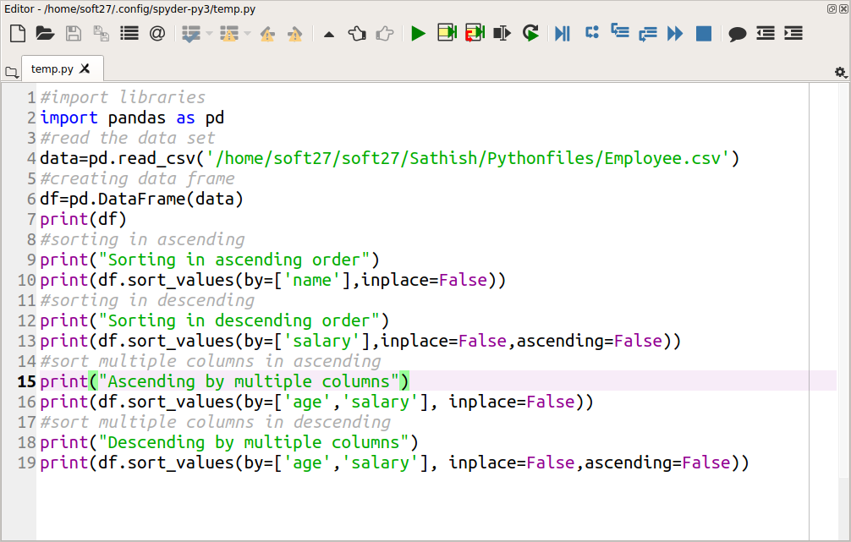

**Output:**

